Welcome to the
FY 2021 Landscape Scale Restoration
Competitive Process On-Line Form
Application Instructions

Getting Started
Step 1 - Each State or Island member of the Council of Western State Foresters (CWSF) will have or has received a password. If you do not have your password, please contact Danielle Okst, CWSF Associate Policy and Grants Director at (303) 835-9911 or DOkst@westernforesters.org.
Step 2 - Go to www.forestrygrants.org and click on the Western LSR Blue Box
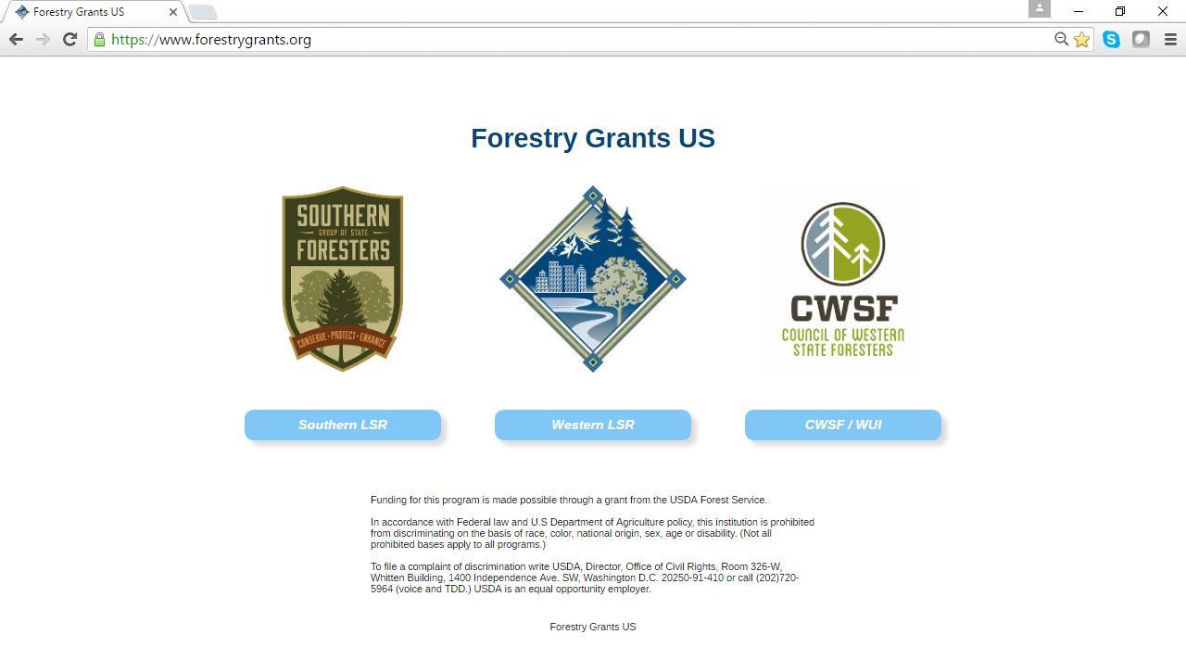
Step 3 – For the current year’s application process, clink on the next screen click on Applicant Login.
To see past years’ applications and scores, click on the blue boxes with the year you want.
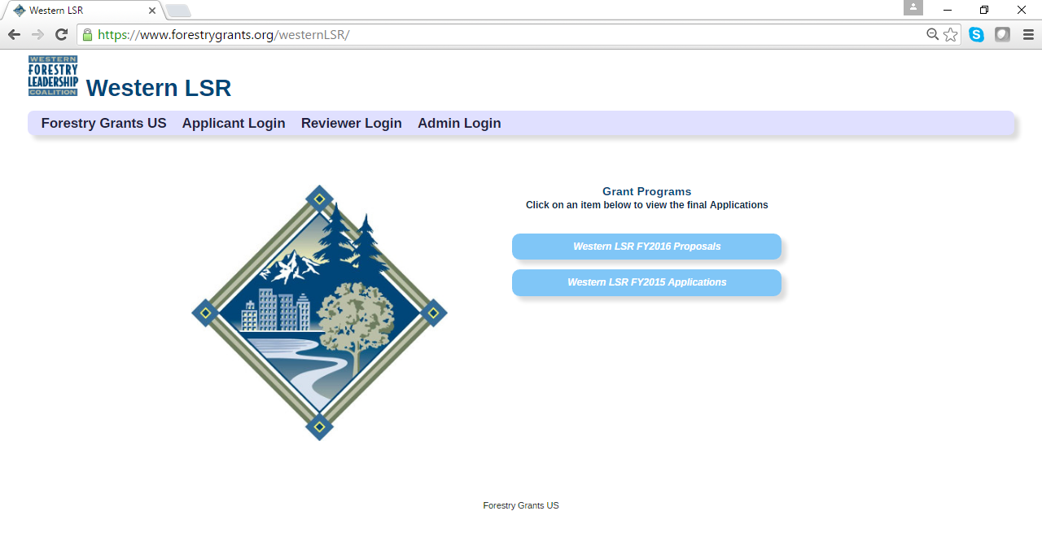
Step 4 – On the next screen you will see the summary instructions. Click on the down arrow next to the “State” for a list of the 23 state and island members of the CWSF
.
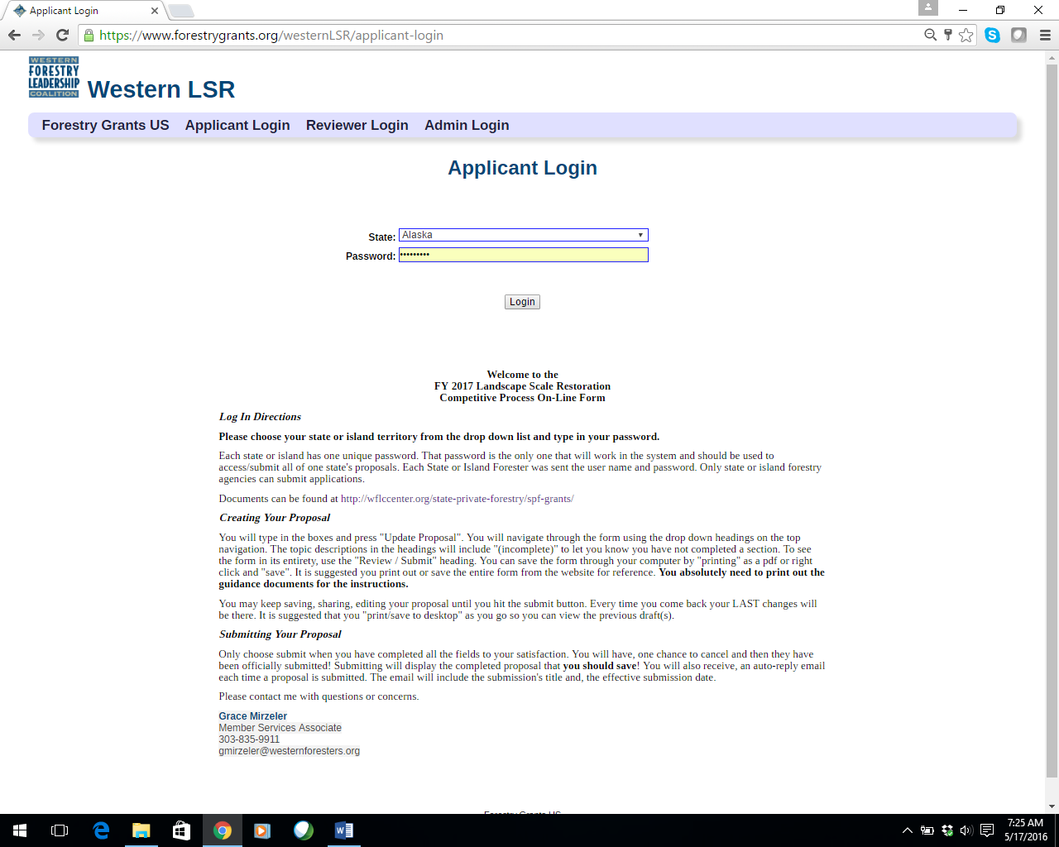
Step 5 - Choose your state or island, enter your password and click Login.
If you run into problems logging in, contact Danielle Okst at (303) 835-9911 or DOkst@westernforesters.org. Do not attempt to login more than three times as you will be locked out for 24 hours.
On the next screen you can start your application according to the guidelines, instructions, and documents provided by the USDA Forest Service and the Western LSR Grants Team. These documents can be accessed directly at https://www.thewflc.org/landscape-scale-restoration-competitive-grant-program/fy-2020-landscape-scale-restoration .

Completing Your Application On-line

Step 1 - To open a new application, clink on “Start Application.” Then select the year and grant you want.

Step 2 - Begin inputting information into your application.

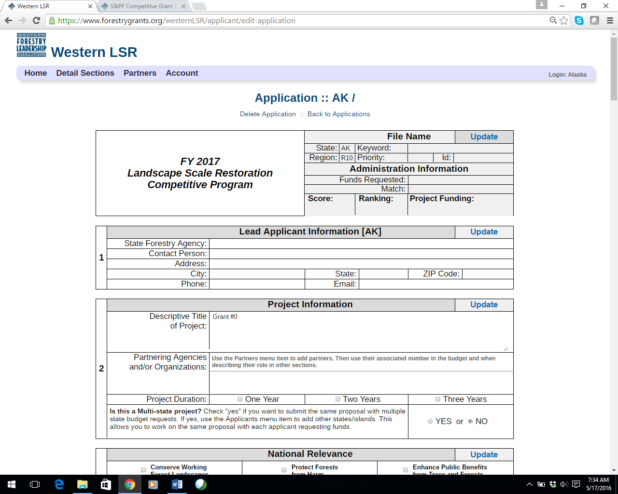
You must fill out the keyword, the rest is administrative. There are no priorities given in western LSR.

REMEMBER: ALWAYS ALWAYS UPDATE BEFORE LOGGING OUT OR MOVING ON TO ANOTHER SECTION!

Fill out and then “Update Proposal.” To complete various sections, simply scroll through the different sections.

Remember to Update Often
After filling out a section or anytime you want to save your work – click the “Update” button. You should do this consistently as you work on your proposal to avoid losing any data in the event of a network interruption or computer issue. Always “Update” before you log out or go to another section

Adding Partners

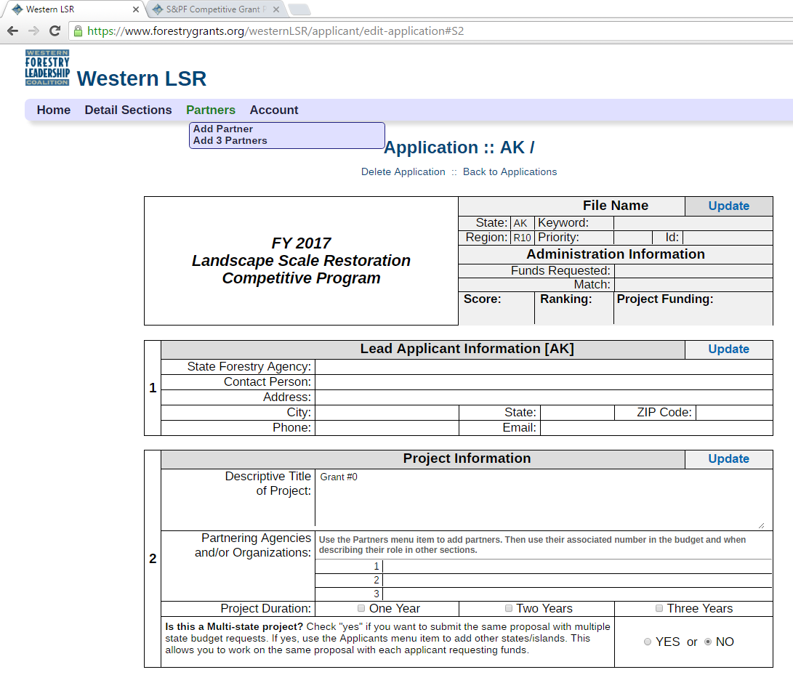
You must update after adding the partners and BEFORE adding more lines, or else the program will cancel the partners already listed.

The “Partners” feature allows you to add one line or three lines at a time to add your partners. Partners are NOT co-applicants. Please read the western guidance for further clarification. You must update after adding the partners and BEFORE adding more lines or else the program will cancel the partners already listed. You will use the NUMBER associated with the partner in your budget box. Reviewers will be able to see their association when they mouse over the number. You may use abbreviations in the narratives if you defined them here, though please note that in the budget, you may only use the Partner number.

Partners (Continued)

Multi-State/Island Proposals
You use the multi-state check box only if the project involves more than one state AND more than one applicant is requesting direct funds. If you choose to submit a multi-state proposal, the multi-state proposal check box must be properly marked on the application. An “applicants” menu will then appear for you to add other participating states and contact information. A co-applicants budget will appear and the proposal will now also appear in the participating states list of proposals. The co-application can complete their contact information and budget. It is the same proposal with only the funding request and budget being unique. The proposal will count toward each state’s maximum submission of five, with each state’s budget limited to a $300,000 request. Therefore, the total request can exceed $300,000. The “lead” applicant is the state/island that begins the application and has a “submit” button. The proposal will receive one ranked position. However, if the project is recommended for funding, it would still be possible for one state to receive funds and another not, due to the 15% cap.
Non-state/island entities that would like to apply for a multi-state project should indicate so in their proposals to the relevant state/island forestry agencies. All state/island forestry agencies where the project will take place should be contacted, and the non-state/island entity can coordinate a multi-state proposal as outlined above or elect to not submit a multi-state proposal and apply separately through each state. Tribes should use this process or alternatively contact the USFS Region(s) where the Tribe and the project are located.

Multi-State/Island Proposals (Continued)
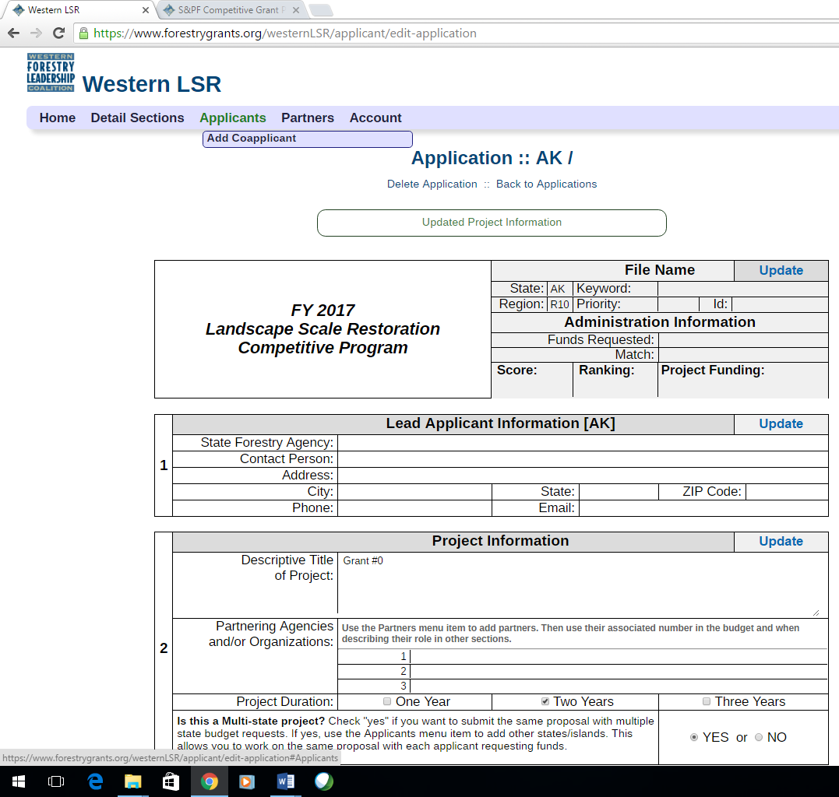
After checking “yes” this feature allows you to add other CWSF states/islands
Multi-State check box that allows the co-applicant feature to appear

(Multi- State Continues on next page)

Multi-State/Island Proposals (Continued)

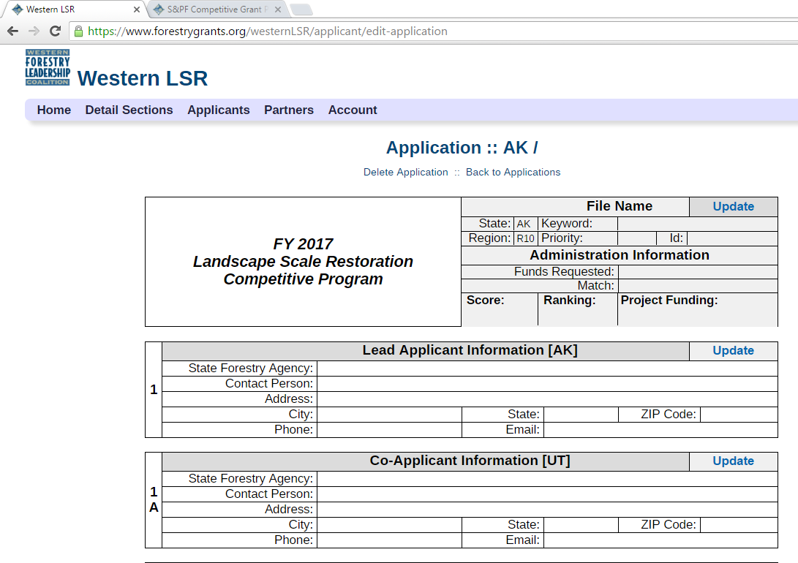

There is now a section for Co-Applicant information and budget. All else is the same.
This proposal will now appear in the co-applicants’ list and count toward their five submissions.

Budget
Whether single or multi-state, you complete each state’s budget separately and the grand total box will compute automatically.

(Multi- State Continues on next page)

Multi-State/Island Proposals (Continued)

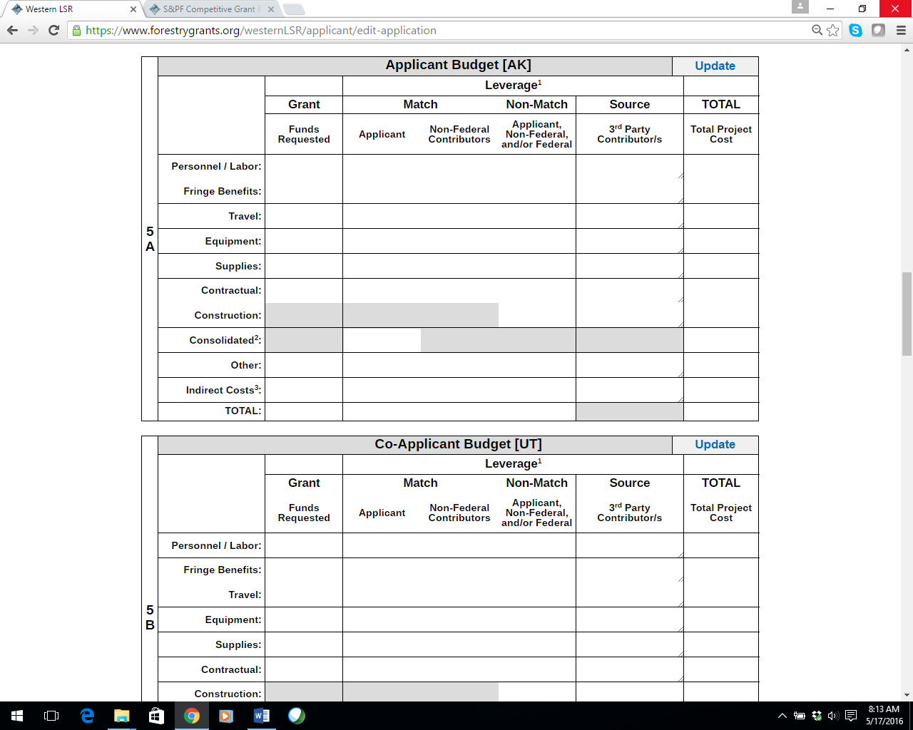

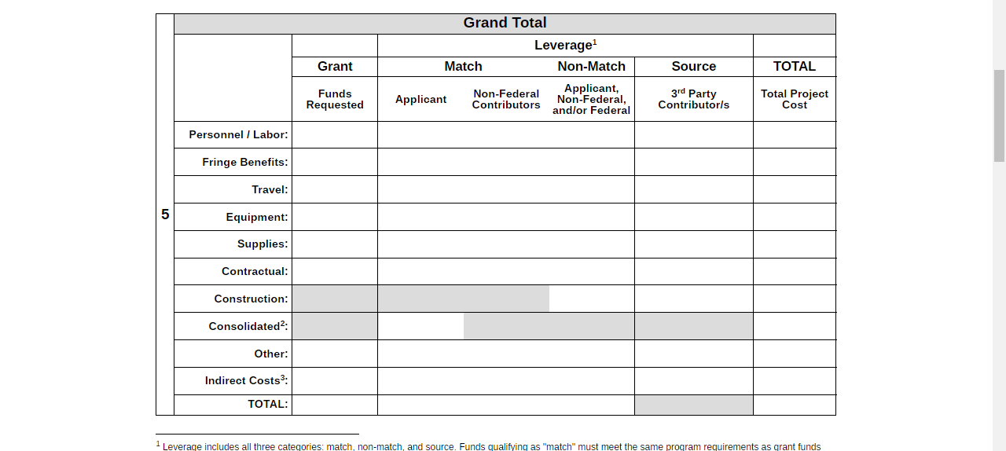

Print/Save and Submit your Proposal

Important: Review and save your proposal before submitting

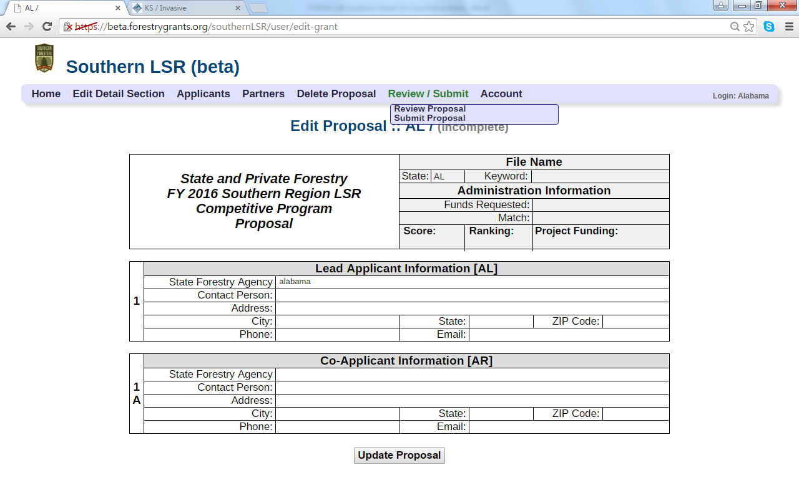

On most computers you can right click or click on the ‘File’ tab at the top of your screen to print (as a hard copy or as a pdf).

IMPORTANT: PLEASE SAVE YOUR PROPOSAL BEFORE SUBMTTING!

In the case of a discrepancy in what you think you submitted and what is actually online, your saved document will be an important piece of documentation.

The “Submit Proposal” button will only allow you to submit if all the sections are filled out. Once you submit, you cannot make changes to your application. An email will be sent to the applicant’s email address noting the proposal and date/time submitted.

